Leetcode question
Perfect Number - LeetCode
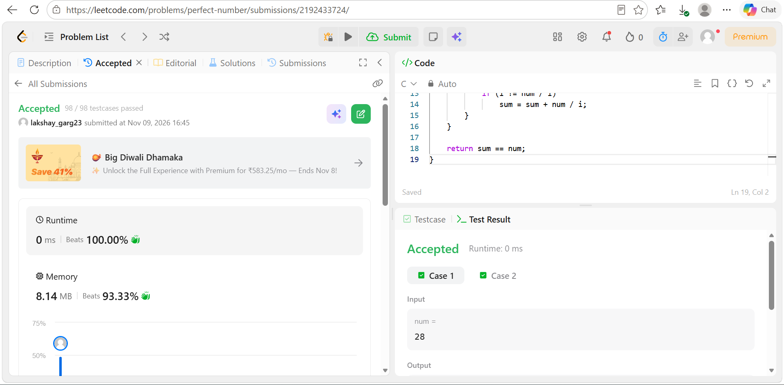
Code
#include <stdbool.h>

bool checkPerfectNumber(int num) {
if (num <= 1)
return false;

int sum = 1;

for (int i = 2; i * i <= num; i++) {
if (num % i == 0) {
sum = sum + i;

if (i != num / i)
sum = sum + num / i;
}
}

return sum == num;
}

